Execrise – 9 : Cricket app

Info: Double clicking on the .js files you can able to see the content



Src/App.js

import React from 'react';

import OddPlayers from './OddPlayers';

import EvenPlayers from './EvenPlayers';

import ListofPlayers from './ListofIndianPlayers';

import Scorebelow70 from './Scorebelow70';

import ListofIndianPlayers from './ListofIndianPlayers';

function App() {

  const flag = true; // Change to true or false to toggle view

  const players = [

    { name: 'Virat', score: 80 },

    { name: 'Rohit', score: 95 },

    { name: 'Dhoni', score: 65 },

    { name: 'Jadeja', score: 45 },

    { name: 'Ashwin', score: 78 },

    { name: 'Shami', score: 34 },

    { name: 'Bumrah', score: 88 },

    { name: 'Gill', score: 76 },

    { name: 'Pant', score: 90 },

    { name: 'Kohli', score: 55 },

    { name: 'KL Rahul', score: 99 },

  ];

  const IndianTeam = ['Virat', 'Rohit', 'Pant', 'Bumrah', 'Pujara', 'Rahane', 'Iyer', 'Surya', 'Shaw', 'Saha'];

  return (

    <div className="App">

      <h1>🏏 Welcome to Cricket App</h1>

      {flag ? (

        <div>

          <h2>List of Players</h2>

          <ListofPlayers players={players} />

          <hr />

          <h2>List of Players having Scores Less than 70</h2>

          <Scorebelow70 players={players} />

        </div>

      ) : (

        <div>

          <h2>Odd Team Players</h2>

          <OddPlayers IndianTeam={IndianTeam} />

          <h2>Even Team Players</h2>

          <EvenPlayers IndianTeam={IndianTeam} />

          <hr />

          <h2>List of Indian Players Merged:</h2>

          <ListofIndianPlayers />

        </div>

      )}

    </div>

  );

}

export default App;

src/EvenPlayers.js :

import React from 'react';

const EvenPlayers = ({ IndianTeam }) => {

  const even = IndianTeam.filter((_, i) => i % 2 === 0);

  return (

    <ul>

      {even.map((player, index) => (

        <li key={index}>{player}</li>

      ))}

    </ul>

  );

};

export default EvenPlayers;

src/OddPlayers.js:

import React from 'react';

const OddPlayers = ({ IndianTeam }) => {

  const odd = IndianTeam.filter((_, i) => i % 2 !== 0);

  return (

    <ul>

      {odd.map((player, index) => (

        <li key={index}>{player}</li>

      ))}

    </ul>

  );

};

export default OddPlayers;

src/ScoreBelow70:

import React from 'react';

const Scorebelow70 = ({ players }) => {

  const below70 = players.filter(p => p.score < 70);

  return (

    <ul>

      {below70.map((player, index) => (

        <li key={index}>{player.name} - {player.score}</li>

      ))}

    </ul>

  );

};

export default Scorebelow70;

src/ListofIndianPlayers.js:

import React from 'react';

const ListofIndianPlayers = () => {

  const T20players = ['Rohit', 'Virat', 'Pant'];

  const RanjiPlayers = ['Rahane', 'Shreyas', 'Gill'];

  const merged = [...T20players, ...RanjiPlayers];

  return (

    <ul>

      {merged.map((player, index) => (

        <li key={index}>{player}</li>

      ))}

    </ul>

  );

};

export default ListofIndianPlayers;

Output :

1) If flag = true

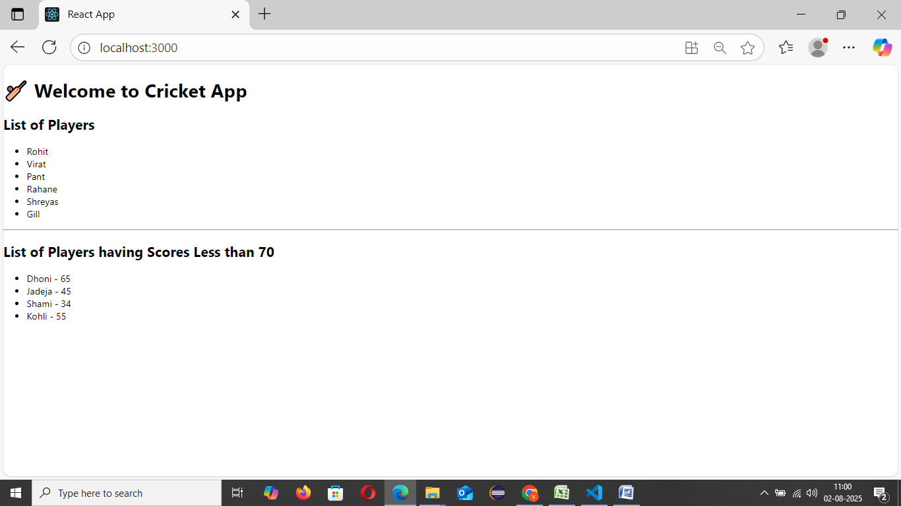

2) If flag = false :

